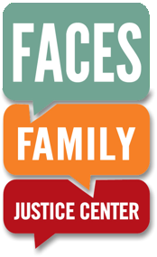
Media Advisory

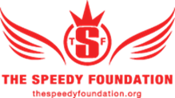
FOR IMMEDIATE RELEASE
July 11, 2016

CONTACT:
Shannon Decker | 208-870-7904 |shannon@thespeedyfoundation.org
Jean Fisher | 208-287-7741

The Speedy Foundation, FACES FaMILY JUstice Center provide MENTAL HEALTH FIRST AID TRAINING
Faces staff, law enforcement and prosecutors learn to identify, address mental health crises

What: The Speedy Foundation (TSF) and FACES Family Justice Center team up to host Mental Health First Aid training for staff members including law enforcement, medical providers, prosecuting attorneys, victim advocates and community resource professionals.

Who: The Speedy Foundation is a non-profit organization dedicated to preventing suicide, supporting mental health and promoting conversations to end the stigma surrounding both. It was formed in 2011 in the loving memory of Jeret “Speedy” Peterson, an Olympic freestyle aerials medalist whose life was characterized by his service to others.
AND
As a department of the Ada County Prosecutor's Office, FACES is a one-stop triage center for victims of abuse, sexual assault, and domestic violence. FACES provides a location and a way of doing business that ensures a safe, private, and supportive setting for victims and their families.

Where: 416 S. 6th Street, Boise, ID; Check in at the front desk of FACES

When: Tuesday, July 12, 2016 at 1:30 p.m.-3:30 p.m. (other times can be arranged by contacting Shannon Decker 208-870-7904 )

Why: FACES identified Mental Health First Aid (MHFA) training as a critical need for their center’s mission and activated The Speedy Foundation’s resources and trainers to rollout the training.

###

About The Speedy Foundation
The Speedy Foundation is a non-profit organization dedicated to preventing suicide, supporting mental health and promoting conversations to end the stigma surrounding both. It was formed in 2011 in the loving memory of Jeret “Speedy” Peterson, an Olympic freestyle aerials medalist whose life was characterized by his service to others. Peterson lived and trained in the Utah Olympic Park for 19 years; he also battled depression and took his own life in July 2011 at age 29.

About FACES Family Justice Center
As a department of the Ada County Prosecutor's Office, FACES is a one-stop triage center for victims of abuse, sexual assault, and domestic violence. FACES provides a location and a way of doing business that ensures a safe, private, and supportive setting for victims and their families. The Center’s multi-disciplinary team includes law enforcement, medical providers, prosecuting attorneys, community resources, legal services, and victim advocates. Ada County provides the facilities at no cost to FACES, and victim services are supported by FACES Foundation. The Center upholds victims' rights, as defined by the Idaho Constitution and Idaho Code.
###

